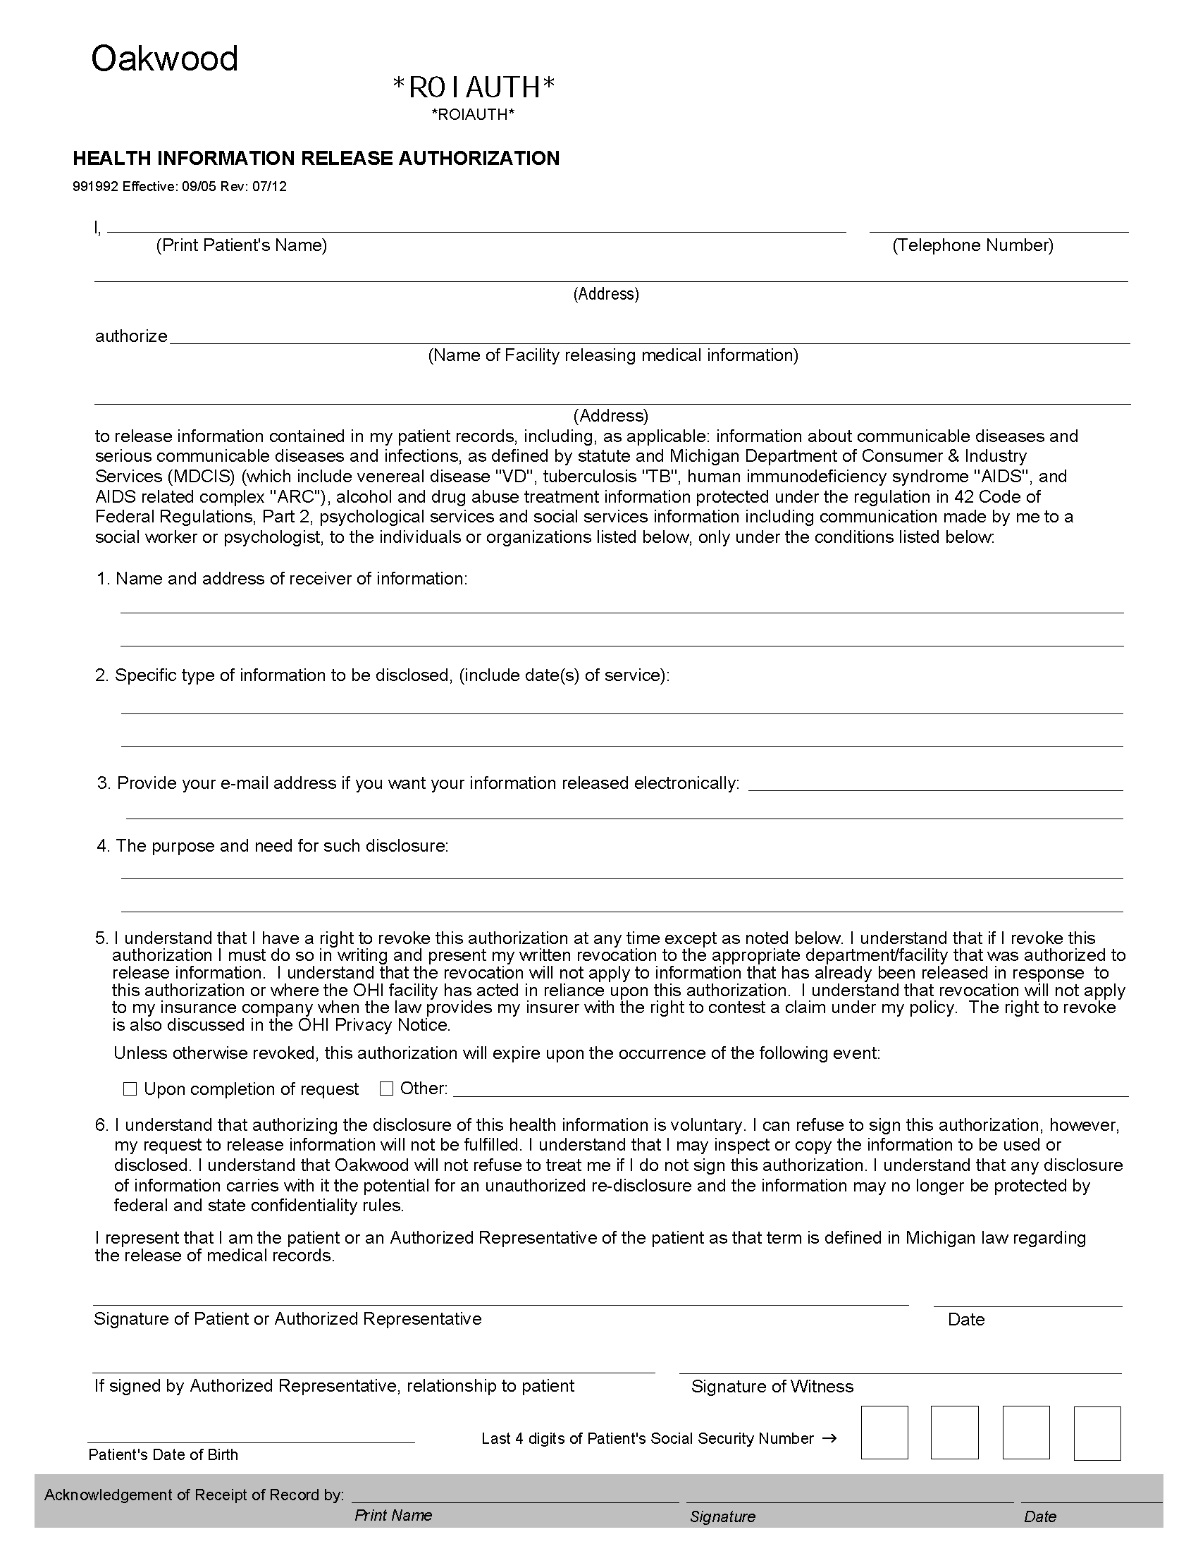

William L. Marrow, Sr.

11834 Culver Country Lane , Webberville, MI 48892
Health Information Management - Poretta Orthopedics
26750 Providence Pkwy., Ste. 200 , Novi, MI 48374
Axiom Requisition Copy Service
As Agent For
The Hanover Law Group
2869 Jolly Road, Okemos, MI 48864
Medical Records
Legal Matter: Marrow v. Fluid Automation, Inc.
Sixty (60) days from the date of signature
02/24/1937
XXX-XX-0837
Order No. 01-31243-001

